

Project Report
(CSE1021) Introduction to Problem Solving and
Programming

Slot-A14+D11+D12, BL2025260100809
Fall Semester: 2025-2026

Name of Student: Akshat Rajput
Register Number: 25BCE10874

Introduction-
“ChemBro” is a python - based educational application designed to help visualize electron shell diagrams and access extensive information about chemical elements. It also contained a detailed dataset of elements including physical, chemical, and configuration details.

The system uses: -
Dictionary- Collection of data stored in key-value pair. Instead of using numbered index to retrieve data we use key to find associated value.
Its Mutable
It is enclosed in { }.
Ex- {“name”: “Akshat”,” Age”:19}
List- An ordered mutable collection of elements. You can add, remove, or change items within a list after it is created.
Syntax- Square Bracket [ ]
Example- [“apple”,” banana”,5,3.14]
String- A sequence of character used to represent text. String is immutable, meaning once created they cannot be changed.
Syntax- Enclosed in single ‘ ’ or double “ “ quotes.
Example- “Hello World”
Tuple- Like list a tuple is an ordered sequence but its immutable.
Syntax- Enclosed in parentheses ( ).
Example-(19,15,” Akshat”)
Functions-It is a reusable block of code that is designed to perform specific task. Instead of typing same code repeatedly we can define a function and call it whenever it’s needed with manipulation in parameter or argument
Turtle- In Build python library that can be used to draw figures as programmed.
Tkinter- In Build python library used for creating user interface (GUI).
PyAutoGUI – Python module used for GUI automation. It allows your python scripts to programmatically control the mouse and keyboard, enabling the computer to perform tasks just as a human user would.

Problem Statement and Objective-
Students struggle to understand the structure of atoms and electron configurations as existing tools are complex to use.
So, this is a simple, intuitive tool that automatically displays electron shell diagrams and retrieves detailed element information from a structured dataset.
Functional Requirement-
- Input Atomic Number
User enter atomic number on terminal
- Calculate Electron Distribution
Use Sequence as 1s,2s,2p,3s to calculated electron distribution.
- Generate Electron Shell Diagram
The Program draw electron shell diagram using turtle first it draws
Nucleus with Turtle than it draws orbit (K,L,M,N) than it generates
Electron on orbit.
- Retrieve Element Data
Program fetch name, appearance, atomic mass, shells, electronic
Configuration and other details from dictionary.

- According to user input in display the output to user like they want to see element details or electron shell diagram.
Non- Functional Requirements-
- Usability- The text interface should be simple, prompting user for numeric
Inputs.
- Performance- Program should be able to render diagram in very less time.
- Reliability- The program is fully on python and standard libraries like turtle, time, tkinter and some 3rd party library like pyautogui, keyboard.
- Accuracy- To provide user accurate data program uses all information scaped from verified source.
- Security- Program runs locally to prevent any type of cyber treat.
System Architecture-
The program uses this architect to produce output: -
- Data Layer- Program uses python dictionary element to produce output.
- Logic Layer-
- Program uses diag() function to calculate electron distribution of element.
- Program uses drawing () function to draw electron shell diagram.
- It uses dictionary retrieval to produce all details about element and

- Presentation Layer-
- Program ask input to what user like only details about element Or Electron Shell diagram.
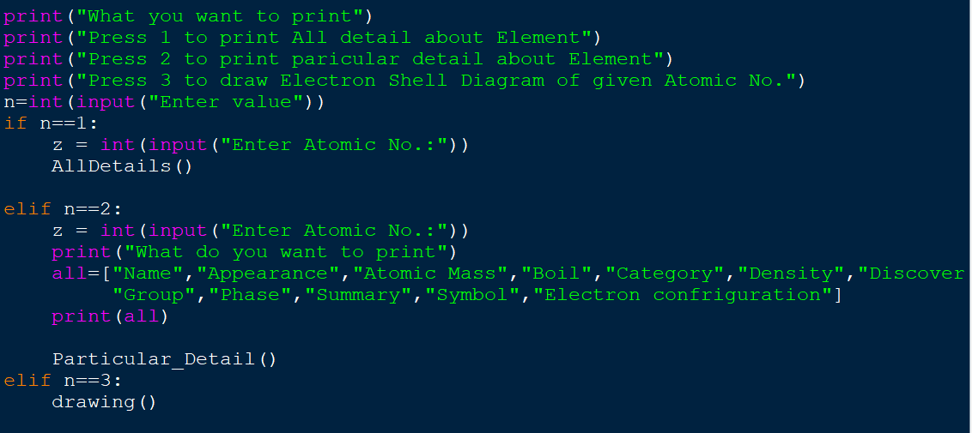
Design Decision & Rationale-
- Data Storage-
All data is stored in a nested dictionary {Atomic No.: {Key: Value}}
Ex-
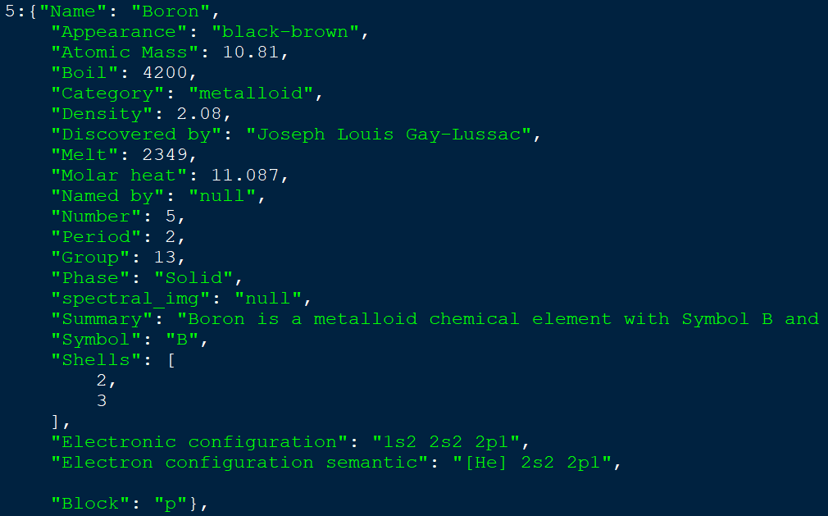
- Visualisation Library –
- Program uses turtle library to draw electron shell diagram.

- Input Automation –
Used pyautogui to maximize window for better visibility.

Implementation Details-
- Library- time, tkinter, turtle, pyautogui, keyboard
- File Contain-
- Element List
- Atomic number
- Shell Sequence
- Electron Distribution algorithm
- Runs the function drawing () which triggers shell calculation and rendering.
Screenshots / Results-
- Input screen-
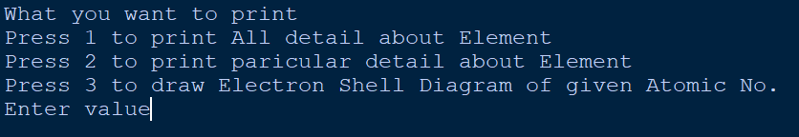
- Element details displayed-
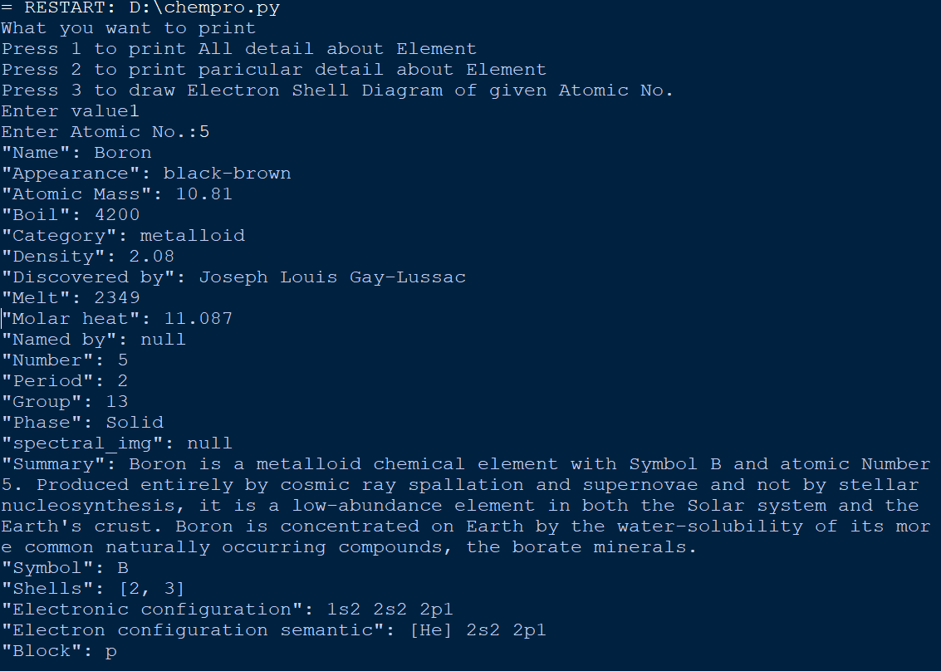

- Specific detail about element displayed-
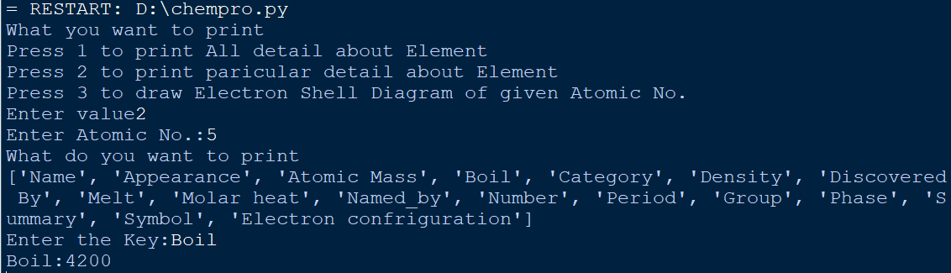
- Shell diagram-
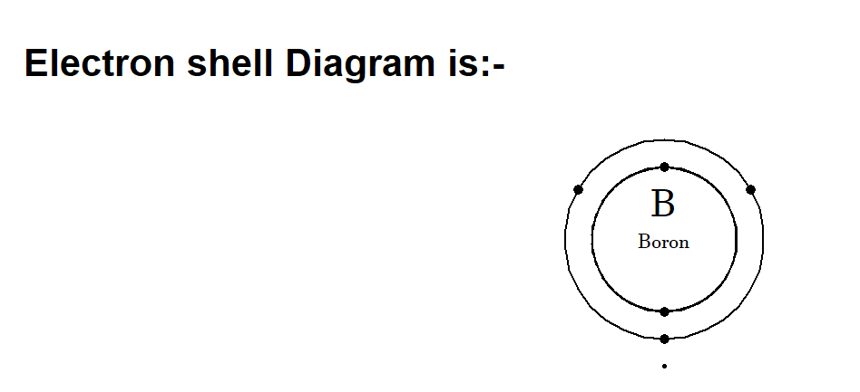

Testing Approach
- Unit Testing (Data): Verified atomic numbers 1 (Hydrogen), 50 (Tin) to ensure the Dictionary contains valid keys and values.
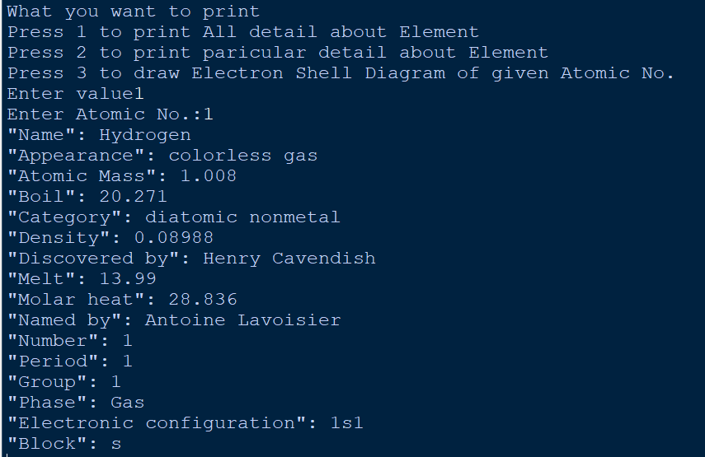
Verification of Atomic Number- 1 (Hydrogen)
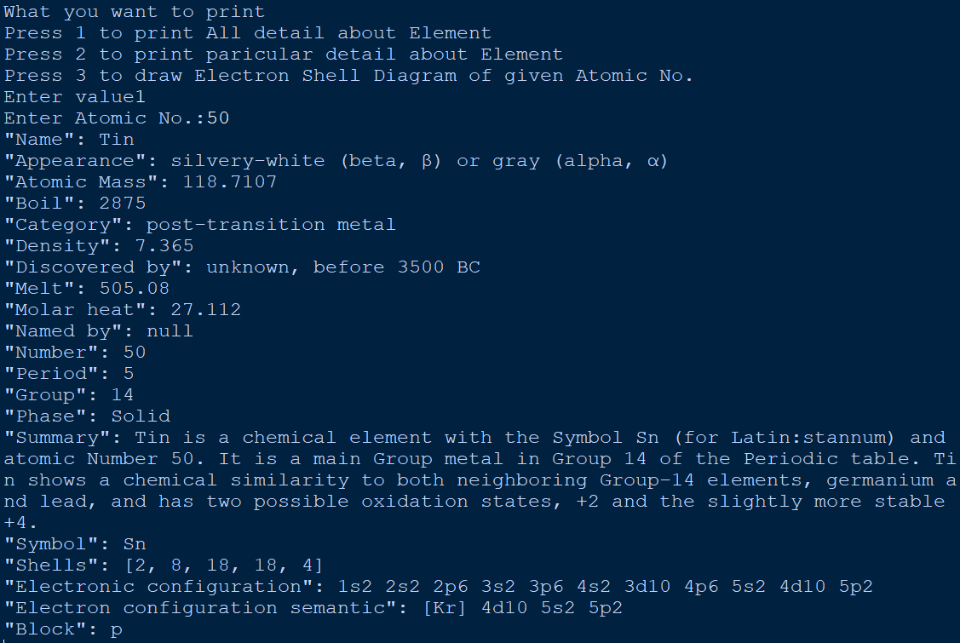
Verification of Atomic Number- 50 (Tin)
- Functional Testing (Drawing):
  - Tested Atomic No. 1: Verified 1 circle, 1 dot.
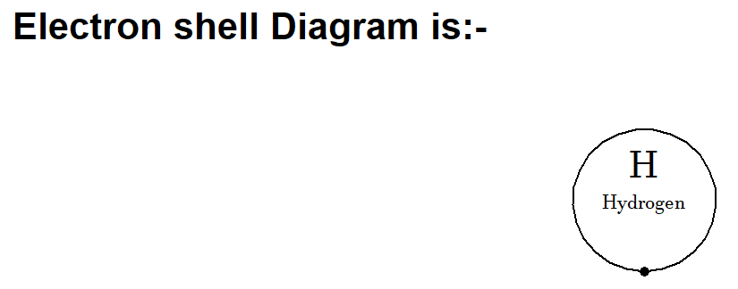
Verification of Atomic No.-1
  - Tested Atomic No. 11: Verified 3 circles (2, 8, 1 config).
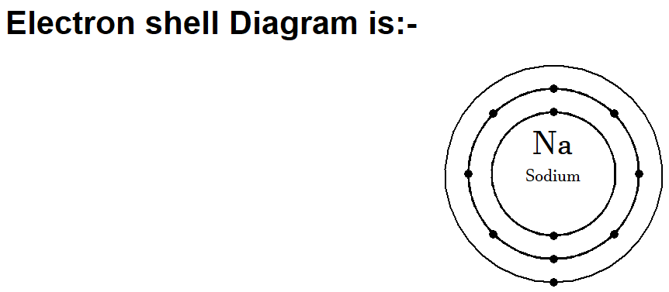
Verification of Atomic No.- 11

Challenges Faced
- Screen Resolution scaling: Using turtle with fixed coordinates (goto(-705, 100)) caused issues on smaller screens. This was mitigated by adding pyautogui to maximize the window.
- Electron Spacing: Mathematically calculating the angle to place electrons evenly around circular orbit was tricky to implement inside the drawing loop.
- Data Entry: Manually entering data for 118 elements was time-consuming and was prone to multiple typo errors.
Learnings & Key Takeaways-
- Data Structures: Gained deep understanding of nested dictionaries in Python.
- Coordinate Geometry: Learned how to manipulate turtle and movement to draw complex circular patterns.
- Library Integration: Learned how to mix console-based logic with GUI-based outputs (turtle + tkinter).
- Function use: Learned how to use function in python.

Future Enhancements-
- GUI Interface: Replace the console input with a tkinter or PyQt form for a more modern look.
- 3D Visualization: Using OpenGL or Python to show 3D orbitals instead of 2D Bohr models.
- API Integration: Fetch element data from a live chemistry API instead of hardcoding it, ensuring data is always up to date.
- Exception Handling: Improve input validation to handle non-integer inputs gracefully.

References-
- Python Documentation: https://docs.python.org/3/
- Turtle Graphics Docs: https://docs.python.org/3/library/turtle.html
- Wikipedia: Source of element data (Mass, Density, Discovery info) as noted in source code comments.

